Influence of Organizational Culture on Training Effectiveness

Uzma Rasool Khan#, Kulsoom Kanwal^ and Urooj Arshad^

#Assistant Professor, Students^, Department of Business Administration, Jinnah University for women, Karachi, Pakistan

Accepted 20 April 2017, Available online 25 April 2017, Vol.5 (March/April 2017 issue)

Abstract

The purpose of the research is to analyze the influence of organizational culture on training effectiveness. Those employees who are working in different organizations are influence from training because they develop themselves more productive, loyal and strong. This study also focuses on organizational culture which helps employees to increase their abilities, knowledge, skills and experience within the organization. Our sample size is of 20 employees from which we get the result through questionnaire about influencing of organizational culture on training effectiveness. This paper is based on quantitative technique in which we come up with the graphical representations. The result shows that majority of the employees are influence by their organizational culture during training

Keywords: Organization culture, training effectiveness

Introduction

Every organization has its own culture beliefs, values and norms. Every organization culture is varying from business to business it depends on organization policy. Organization culture is defined as it is a system of expectations, ethics, attitude and principles which oversee that how employees response in an organization.
Training is a short term process by which a human resources gain knowledge, skills and abilities by practical activities to improve their performance. The purpose of the Training is to deliver the skills to undertake a duty or work. It improves the organization productivity and flexibility. Training helps employees to do work in an effective and efficient manner.

Research objectives

- To find out the effectiveness of training of employee performance according to the organization culture.
- To study the behavior of employees on training to influence the culture of organization.

Scope of the research

This research focuses on the effectiveness of training of employees which influence the organizational culture and their organization performance. From the organizational point of view training is beneficial for both employees and organization as well. It helps organization to achieve their task effectively and efficiently. Moreover, training influence employee performance in organization to build vast organizational culture. One of the core aims of training is to build strong, proficient and capable employee for productivity.

Research question

- What is the effectiveness of training of employee performance according to the organization culture?
- What is the behavior of employees on training to influence the culture of organization?

Limitation of the study

- Due to the limitation of time. So, we take less response.
- Our sample size is 20 it could be further exceeded.
- Data was collected by those employees who work in an organization either on job or retired.

Literature review

Studies of the influence of organizational culture on training effectiveness have become more intensive on the levels of capabilities that are essential for acquire platform contented. Motivational and conservational effects of training effectiveness have been acknowledged slight attention. This examination assimilates important factors of motivation and environmental effects on organizational culture as well as organizational behavior concept and study which defines that how organizational culture may influence the effectiveness of training. (A.Noe, 1986).
Training helps individuals to work with each other and give their best and express them how to do their work more effectively and efficiently and more securely. It diminishes the stretch and it takes employees to regulate and acclimatize to an innovative work atmosphere, curtails client criticisms, decrease coincidences and subsidizes to your corporate product worth. Training contemporary employees is a necessity to meet the tactical needs of your corporate and when collective with a knowledge and organizational culture can significantly reinforce your corporate. (vercoe, 2012).
A culture in your professional can means to assemble definite that proposes by consumers and staff are proceeded on it and supervise the opportunity to modify their jobs within the organization to be multi-skillful or to be accomplished from within an organization and training chances are providing to construct on their present facilities. If we embolden a culture within our organization, one where people are frequently and relocate this culture through the organization, then the corporate itself endures to cultivate and progressive. In the core it is the growth of Mortal Wealth that is our main strength in occupational areas today. Each employee in your corporate has the impending to offer results, fascinate and preserve clients and create an influential change to your profession and delivered you capitalize in their training. (cole, 2010).
Certainly, the mentor’s competences as a matter trained would regulate the effectiveness of the training and development in corporate. Training programs can be underestimate if the organization hire an inexperienced trainers that could failing the transmission of erudition to the employees. Moreover, employees’ arrogance and enthusiasm are one of the major features that would be impact the effectiveness of training and development. Consequently, the optimistic attitudes should be raise from side to side where the continual importance on team structure platform to improve the employee motivational exertion. In relative to this, the employee incentives in relocation and transmission of culture are vital to certify the effectiveness of training in an organizational culture. (Jossey-Bass, 1990).
Lastly, the assurance of top management to the training and development is critical to its success. Organizations whose top management view training as a way to meet organizational goals by making sure that employees take an active part in the delivery of training and in the planning of training objectives; and by maintaining a financial commitment to training. (facteau, 1995).
(Md zabid Abdul Rashid, 2004) Conducted the research on how organization culture influences the attitude toward organization change in Malaysia. Data was collected to 258 companies listed in the federation of Malaysian manufacturing directory. Structures questionnaire are design. Research shows that there is relationship between organization culture and the affective cognitive toward organization change. Moreover different organizations have different acceptance level toward organization change. It means that some organization cultures accept the change and some are not accept the change.
(Heather C. Kissack, 2010) This research claimed that training and development program influence on organization culture. Researcher used the Gideen’ structuration theory, this paper theoretically applies in training and development program within organization. Researcher fined the theoretical relation between organization culture and each step of training. During the implementation of a training and development program many problems are alleviate because of culture resistance and a conflict between culture and training.
Researcher performed the study on organizational transfer climate and positive transfer of training, discuss on either trainee transfer learn from their training program or not. This research was conducted in a large franchise which was operated in a one hundred Fast-food restaurant in large metropolitan areas. Study also shows that those trainees manager who are assign training program are more better perform their job and had a more positive organization climate. Moreover manager trainees who learned during the training are more productive and perform better on job. Furthermore researcher suggests that organization transfer climate is a tool which enhances the positive transfer of training in the work environment (Janice Z. Rouiller, 1993)
Training plays an important role in organization. This research focused on either training influence the trainee characteristics in the training program or not. Further said motivation and environmental factor is also influence on training effectiveness. Researcher apply the exploratory model and describe the relation that how training outcome influence on trainee career and job attitudes (Raymond A. Noe, 1986)

Methodology

This study is focused on quantitative research and the primary data was collected through questionnaire which was conducted by 20 employees who works in different organization of Karachi, Pakistan. The research tool which we use in this research is questionnaire, and we use histogram and pie chart as a statistical tool through SPSS.
Data Analysis

Graphical Representation: (pie chart)

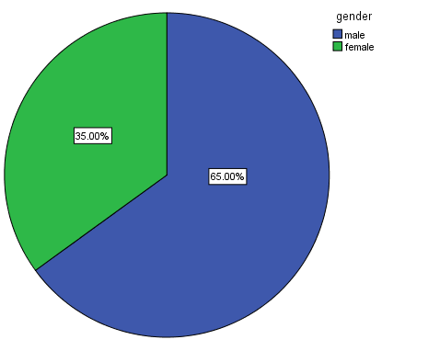
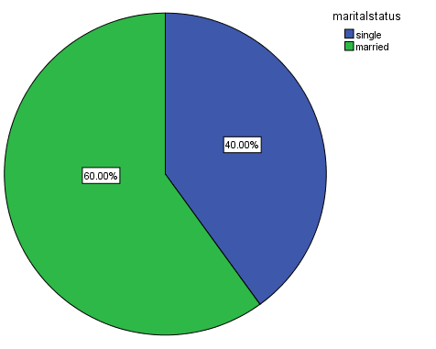

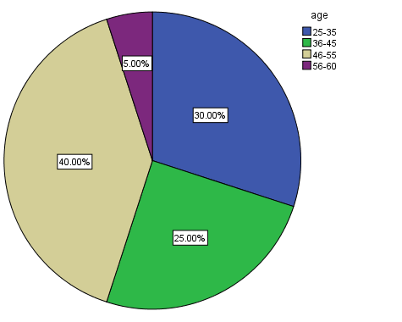

Interpretation

From these chart it shows that there are 65% male and 35% are female in which 60% are married and 40% are single. Majority of the working men and women are between the ages of 46-55.

Histogram

Time Horizon

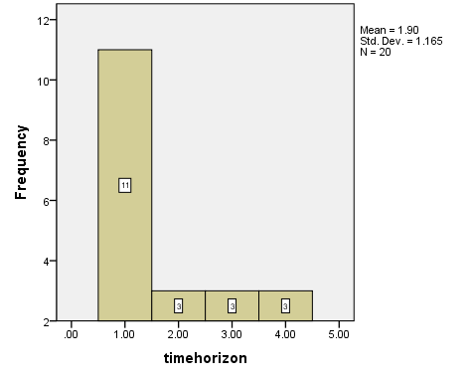

Interpretation

It shows that out of 20 respondent 11% employees are working for less then10 years in an organization and remaining employees are work for more then10 years.
Organizational growth

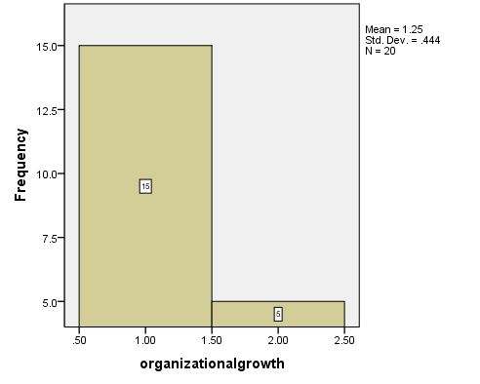
Interpretation

The above chart illustrate that 14% respondent said that training influence the organizational growth for their productivity and the 6% respondent are not agree.

Performance Effectiveness

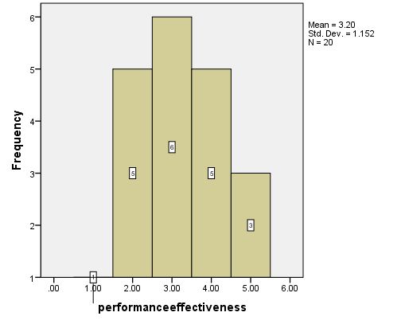
Interpretation

Majority of the respondent said that sometimes organization conduct a performance effectiveness assessment to assess the current situation during training and some said mostly or rarely an organization conduct a performance effectiveness during training.

Cognitive Abilities

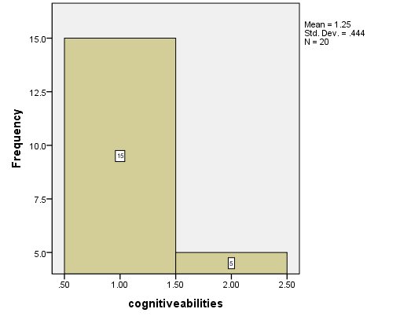

Interpretation

Majority of the employees are agreeing that training improves their skills, knowledge, attitude change, new capability in an organizational culture. But only few of them are not agree with this statement.

Training Expenditures

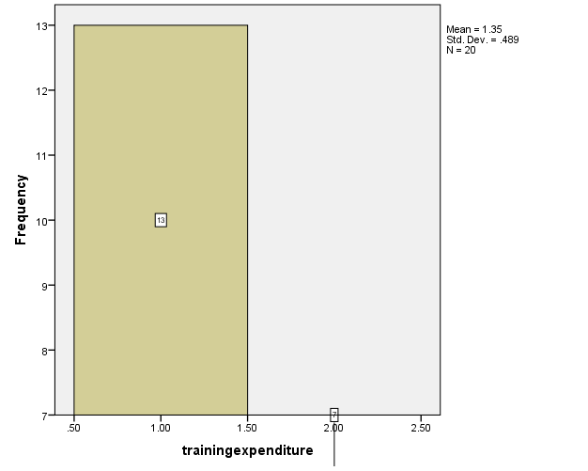

Interpretation

The above graph shows that 13% of the employees think that organizational culture is effective from the training expenditures and 7% do not think in their opinion.

Training Method

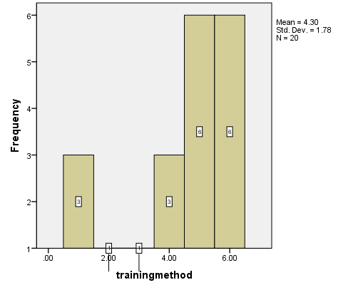

Interpretation

Majority of the organization gives both on the job training and off the job training some gives only lectures and show audio visuals in their organization. Few organizations just give on the job training to their employees.

Motivational level

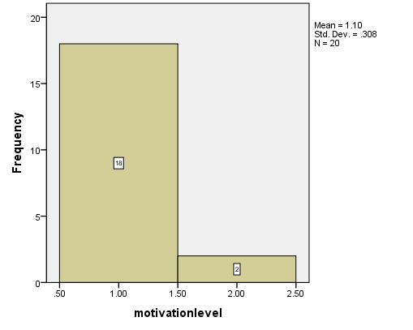
Interpretation

It shows that 18% of the employees are motivated through training and few are not motivated because of lack of interest.

Effective Training

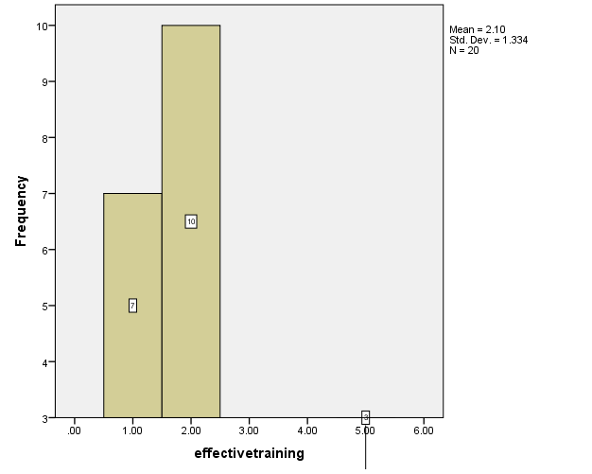

Interpretation

When we asked that ‘Does the training method develops the organization effectiveness?’ so, 7% are strongly agree, 10% are agree and just 3% are neither agree nor disagree.

Employee Relationship

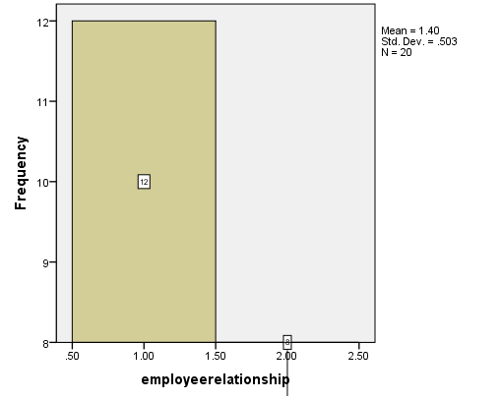

Interpretation

Minority of the employees are not agree with training which helps to improve employee relationship. Hence, 12% of employees are agreeing with training that helps to improve employee relationship in an organizational culture.
Well-planned Training

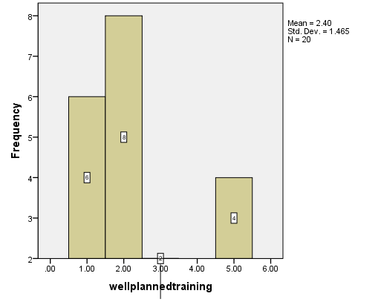
Interpretation

8% of the employees are strongly agree, that training is well-planned in their organization. 6% are agreeing with their well-planned training but, 4% employees are neutral that training is well-planned in their organizational culture or not.

Finding and discussion

In this study it analyzes that majority of the employees influence by training in their organizational culture. Moreover, their skills, knowledge, attitude change, new capacities are improve by training and it also improves employee relationship and develops the organization effectiveness. Fewer employees are not agree with their training because it does not effect on them and also not influence the organizational growth for their productivity.

Conclusion

Organizational culture plays an important role in every organization. Some organization has strong culture and some are not. In organization, training is very necessary for the effectiveness of employees.

Well-planned training is beneficial for the organizational growth because it improves the relationship between employees and also increases their motivation level. Many organizations provide different training methods to train their employees because trained employees are more productive and supportive for their organization to develop their organizational efficiency.
It concludes that training is very essential for organizational culture because organization evaluate the employee performance effectiveness from training. Training expenditure is effective for organization culture to improve employee cognitive abilities and organization growth.

References

- A.Noe, R. (1986). Trainees Attributes and Attitudes Influence On Training Effectiveness. ACAD, 736-749.
- Cole, K. (2010). Management Theaory and Practice. Bax, 1120.
- Heather C. Kissack, J. L. (2010). The Reciprocal Influence Of Organizational Culture And Training And Development Programs: Building The Case for a Culture Analysis Within Program Planning. Journal of European Industrial Training, Vol. 34 Iss: 4, Pp.365 - 380, 34(4), 365-380.
- Janice Z. Rouiller, I. L. (1993, December). The Relationship between Organizational Transfer Climate and Positive Transfer Of Training. The Re Human Resource Development Quarterly, 4, 377-390.
- Jossey-Bass. (1990). The Role Of Climate And Culture In Productivity. Research Gate, 282-317.
- Md Zabid Abdul Rashid, M. S. (2004). The Influence of Organizational Culture On Attitudes Toward Organizational Change. Leadership & Organization Development Journal, 25(2), 161-179.
- Raymond A. Noe, N. S. (1986). The Influence of Trainee Attitudes on Training Effectiveness: Test of a Model. Personnel Psychology, 39, 497-523.
- Vercoe, P. (2012). Organizational Cilture And The Value Of Training. PPD.

